# Computer Science project

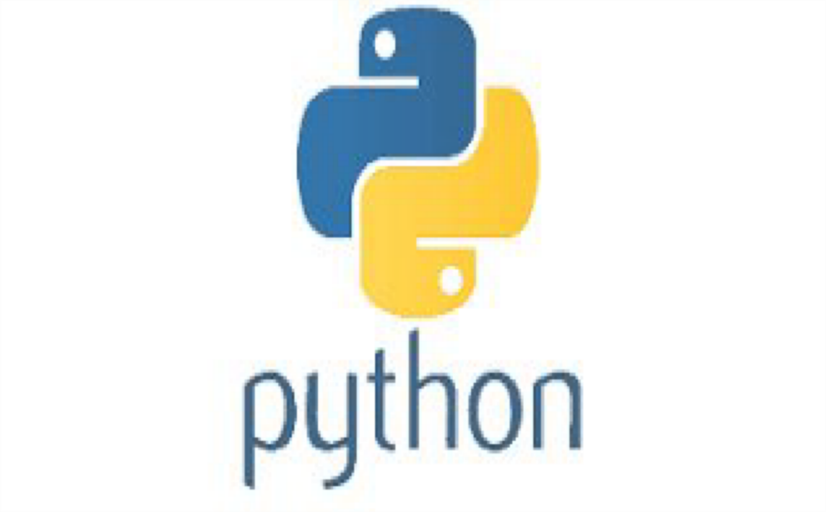

Topic: Image extractor and text compiler Class: XIth A2

Made by: Paritosh

 **Podar International School, Ahmedabad**

**CERTIFICATE**

# This is to certify that , a student of class XII, has successfully completed the research project on the topic “

”, under the guidance of

.

# References taken in making this project have been declared at the end of the report.

## Principal Teacher In-charge External Examiner

**ACKNOWLEDGEMENT**

I hereby acknowledge my deep sense of gratitude and indebtedness to the following personalities whose immense help, genius guidance, encouragement, necessary suggestions, initiations, enthusiasm and inspiration made this work a master art and a joint enterprise.

:- (Principal)

:- (PGT )

## What is python?

Python is an interpreted high-level general-purpose programming language. Its design philosophy emphasizes code readability with its use of significant indentation. Its language constructs as well as its object-oriented approach aim to help programmers write clear, logical code for small and large-scale projects.

## How can python help us ?

Python isn't only for programmers and data scientists. Learning Python can open new possibilities for those in less data-heavy professions, like journalists, small business owners, or social media marketers. Python can also enable non-programmer to simplify certain tasks in their lives. Here are just a few of the tasks you could automate with Python:

* Keep track of stock market or crypto prices
* Send yourself a text reminder to carry an umbrella anytime it’s raining
* Update your grocery shopping list
* Renaming large batches of files
* Converting text files to spreadsheets
* Randomly assign chores to family members
* 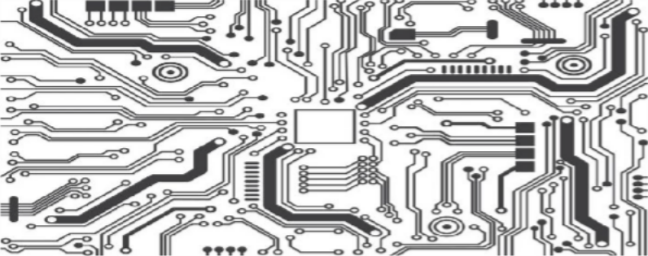Fill out online forms automatically

## What is Python used for?

Python is commonly used for developing websites and software, task automation, data analysis, and data visualization. Since it’s relatively easy to learn, Python has been adopted by many non- programmers such as accountants and scientists, for a variety of everyday tasks, like organizing finances.

What are the advantages of Python?

1. Easy to Read, Learn and Write
2. Improved Productivity
3. Interpreted Language
4. Dynamically Typed
5. Free and Open-Source
6. Vast Libraries Support
7. Portability

## Why is python so popular?

When Guido van Rossum was creating python in the 1980s, he made sure to design it to be a general-purpose language. One of the main reasons for the popularity of python would be its simplicity in syntax so that it could be easily read and understood even by amateur developers also that’s why Python language is incredibly easy to use and learn for new beginners and newcomers. The python language is one of the most accessible programming languages available because it has simplified syntax and not complicated, which gives more emphasis on natural language. Due to its ease of learning and usage, python codes can be easily written and executed much faster than other programming languages.

## What are the disadvantages of Python?

1. 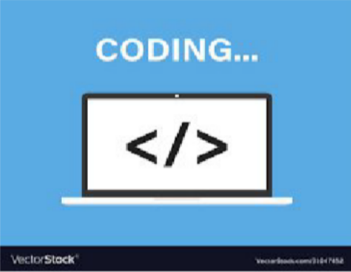Slow Speed
2. Not Memory Efficient
3. Weak in Mobile Computing
4. Database Access
5. Runtime Errors

## Summary

Python is a **simple**, **versatile** and a complete **programming language**. It is a great choice for beginners up to professionals. Although it has some disadvantages, we can observe that the advantages exceed the disadvantages. Even Google has made Python one of its primary programming languages.

Bibliography:

[https://techvidvan.com/tutorials/python-advantages-and-](https://techvidvan.com/tutorials/python-advantages-and-disadvantages/) [disadvantages/](https://techvidvan.com/tutorials/python-advantages-and-disadvantages/)

[https://www.coursera.org/articles/what-is-python-used-for-a-](https://www.coursera.org/articles/what-is-python-used-for-a-beginners-guide-to-using-python) [beginners-guide-to-using-python](https://www.coursera.org/articles/what-is-python-used-for-a-beginners-guide-to-using-python)

https://www.python.org/doc/essays/blurb

Topic: Image extractor and text compiler Code:

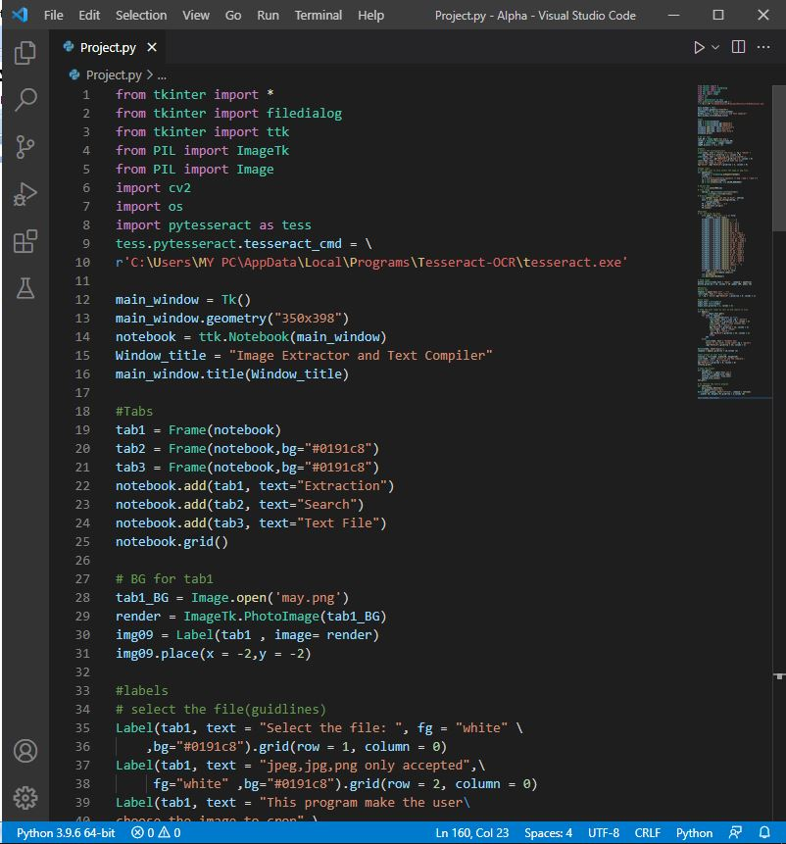

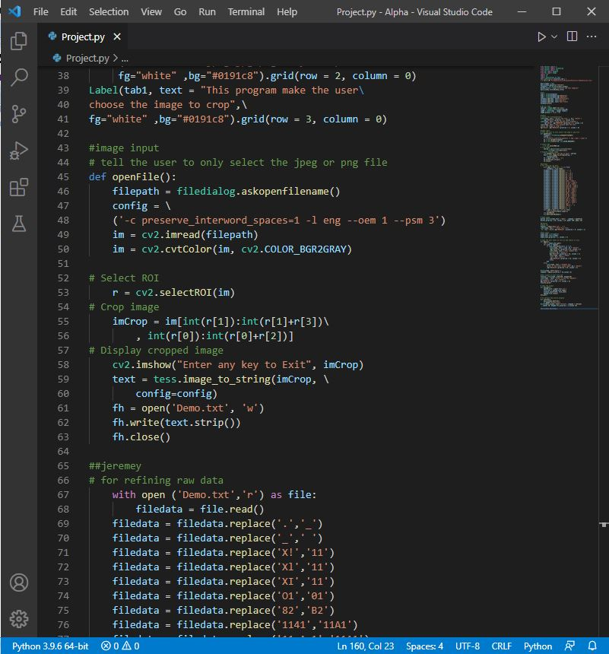

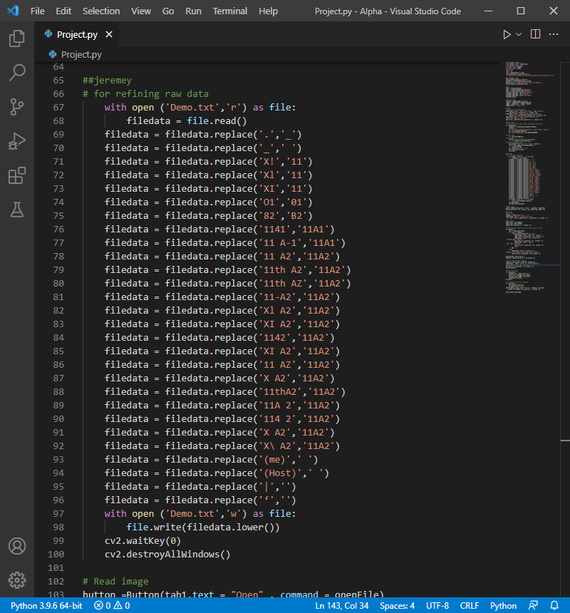

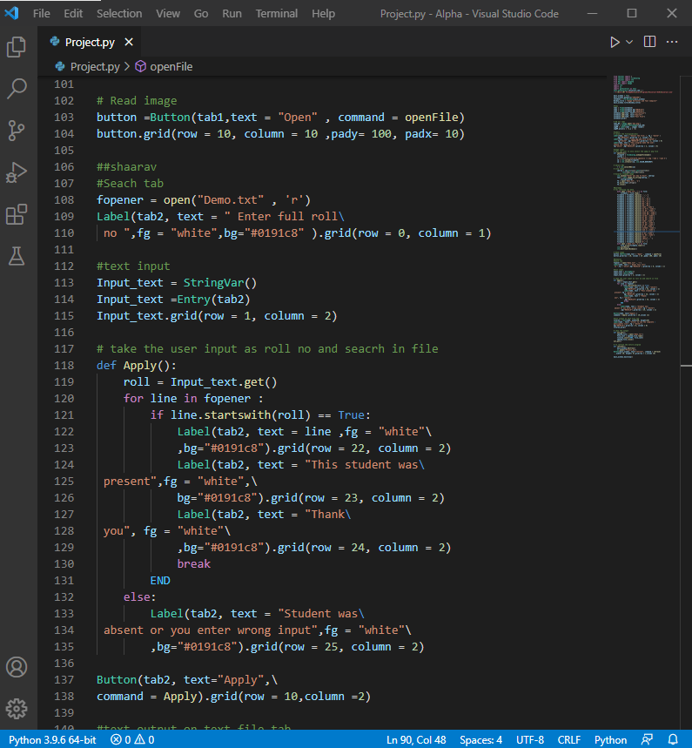

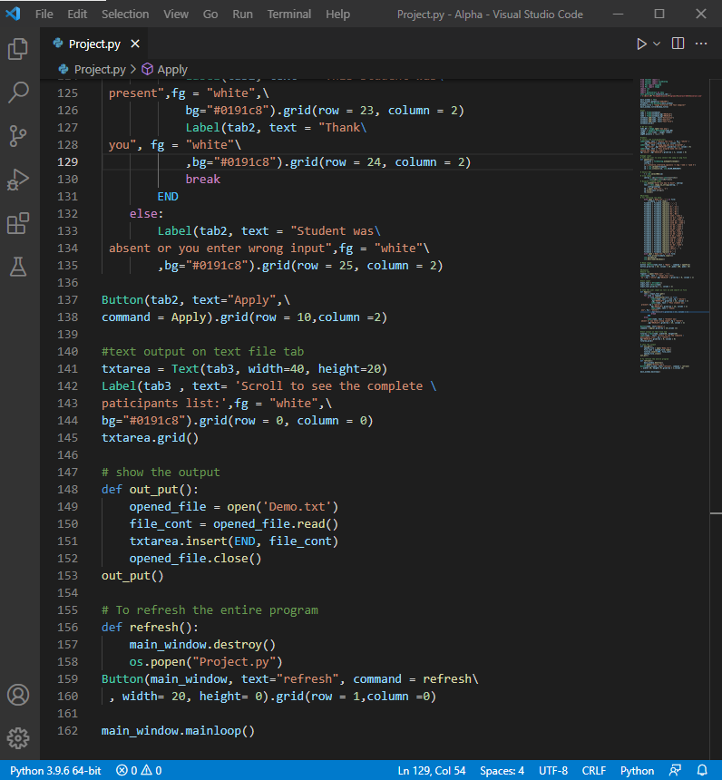

Output:

